Olan, Jayvee T.

Part 1 — Settings, Shared Variables and apiFetch()
setup-01-api-running: part-01-settings-apifetch

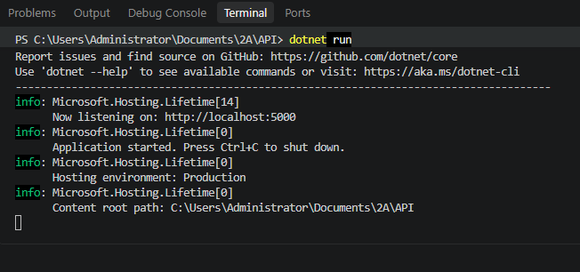

setup-02-api-books-json: part-01-settings-apifetch
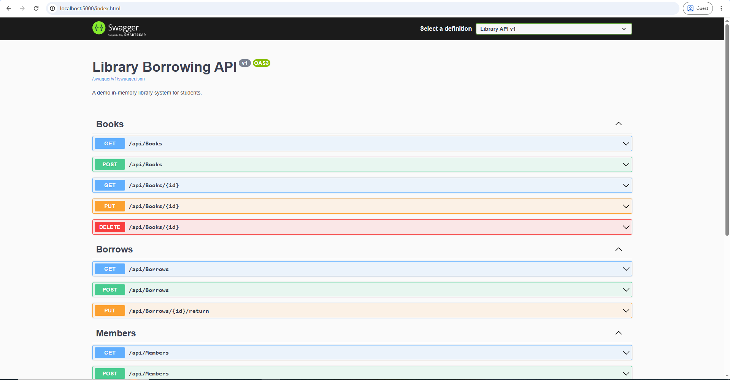

Part 2 — Toast Messages

part-02-showtoast
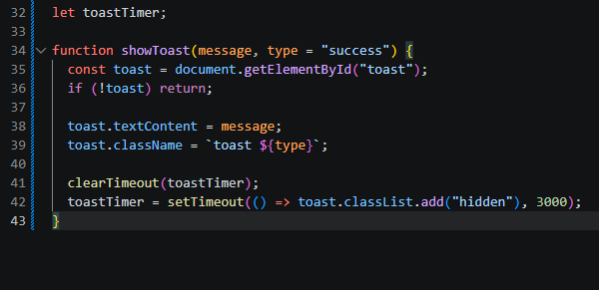

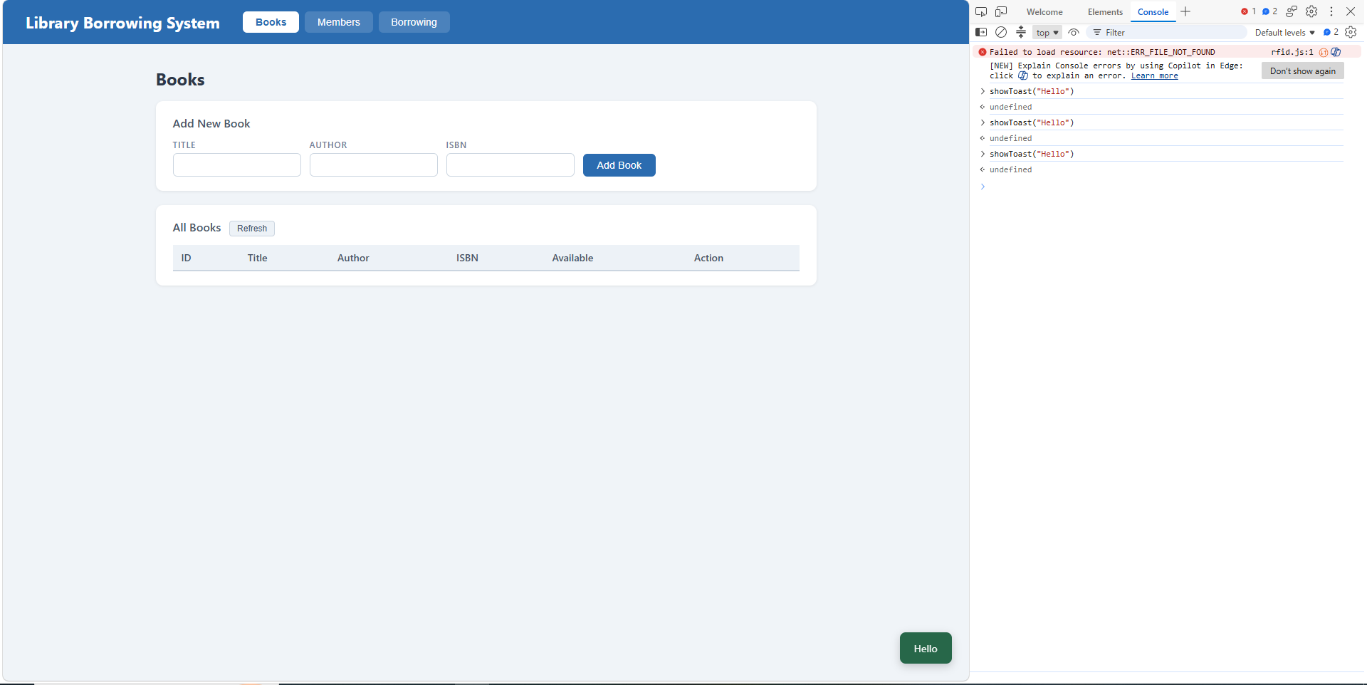

Part 3 — Caches and Find Member by RFID

part-03-caches
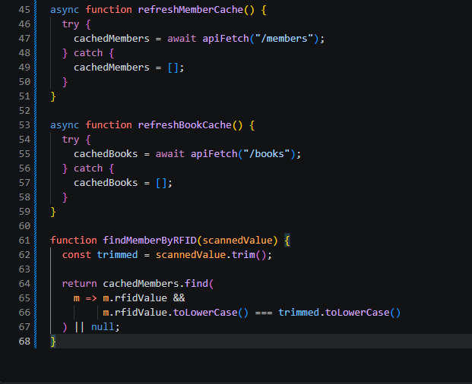
QUICK CHECK
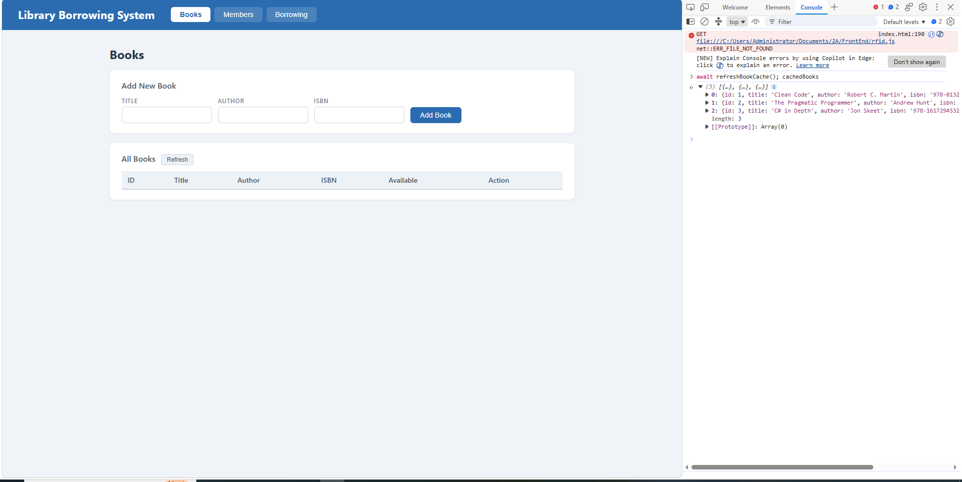

Part 4 — Tabs and Refresh Buttons

Part-04-tabs-refresh
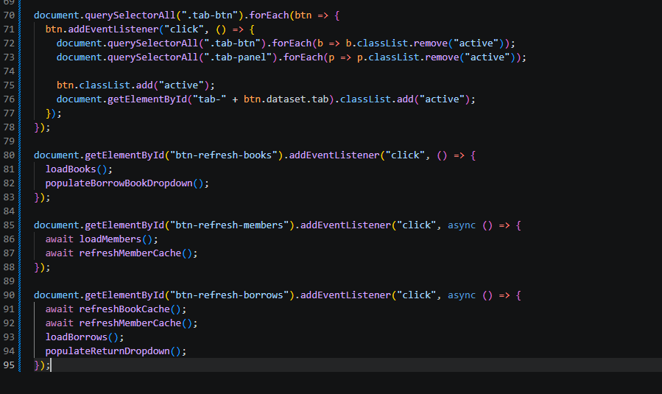
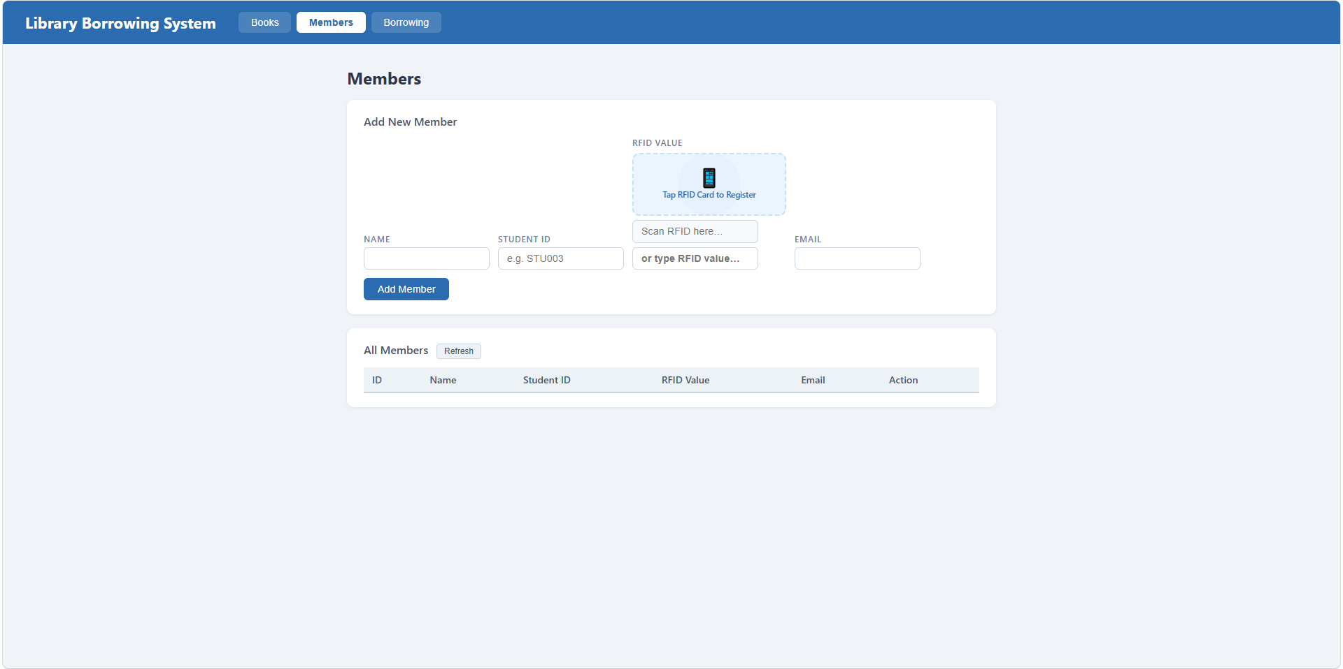

Part 5 — Load Books into Table

part-05-loadbooks

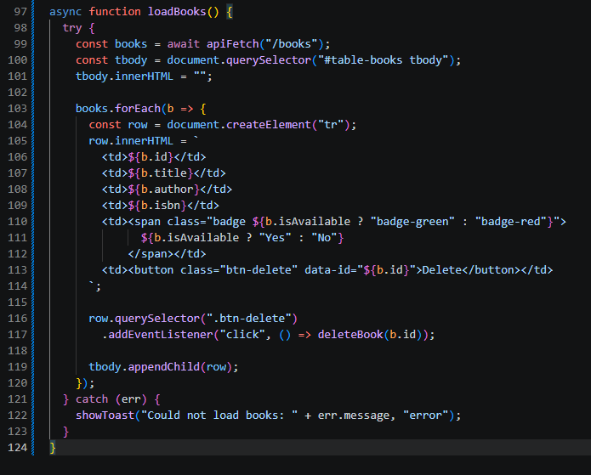

Part 6 — Delete Book

part-06-deletebook
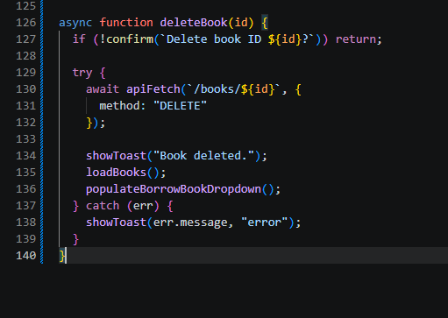

Part 7 — Add Book

part-07-addbook
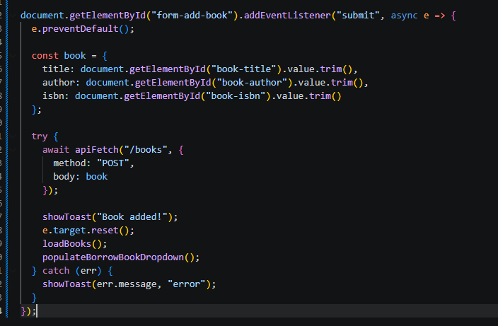

Part 8 — Load Members into Table

Part-08-loadmembers
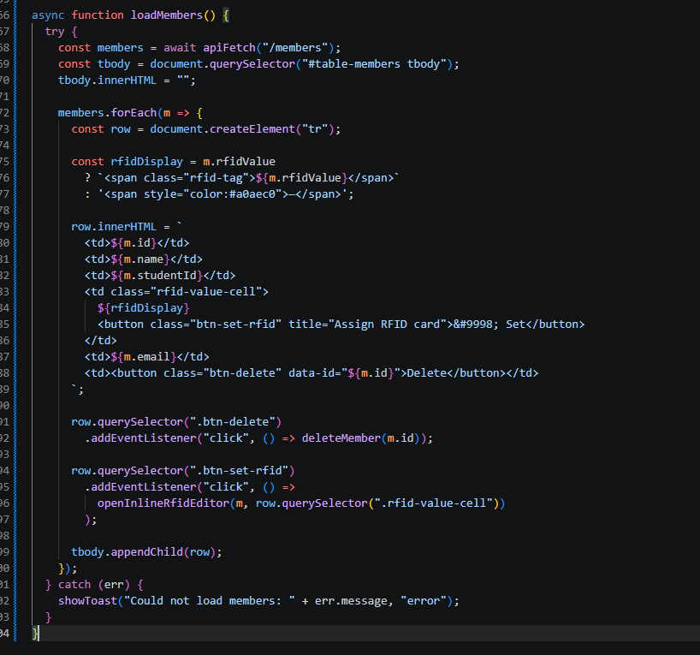

Part 9 — Delete Member

Part-09-deletemember
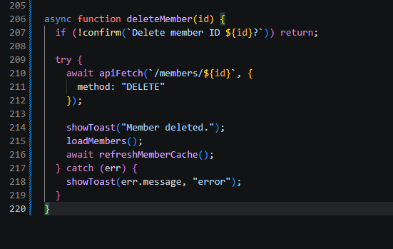

Part 10 — Add Member with RFID

Part-10-addmember
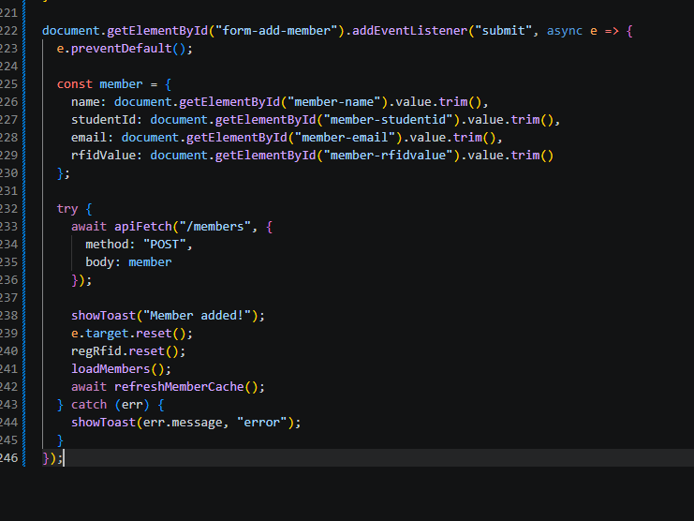

Part 11 — Inline RFID Editor and Update Member RFID

Part-11-inline-rfid-editor
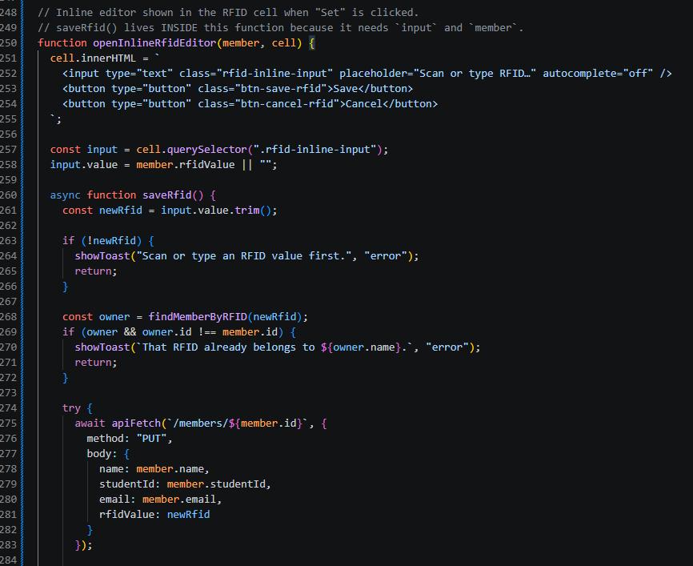

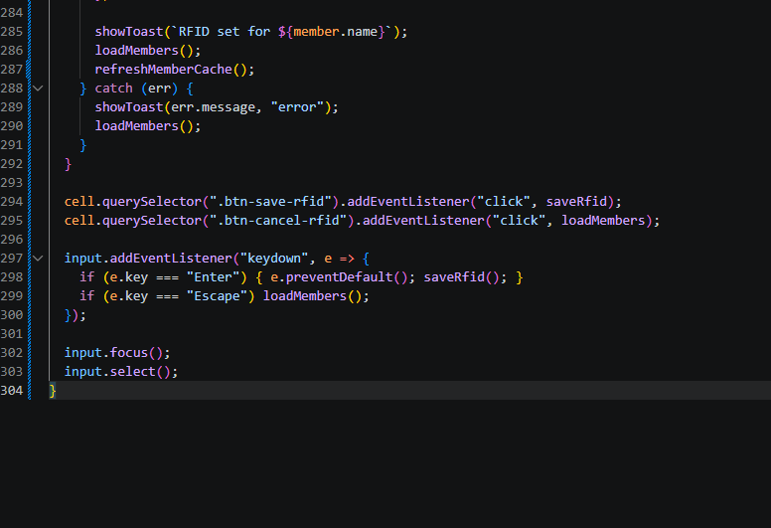

Part 12 — RFID Widgets (Borrow, Register, Return)

part-12a-rfid-widget-builder
1.
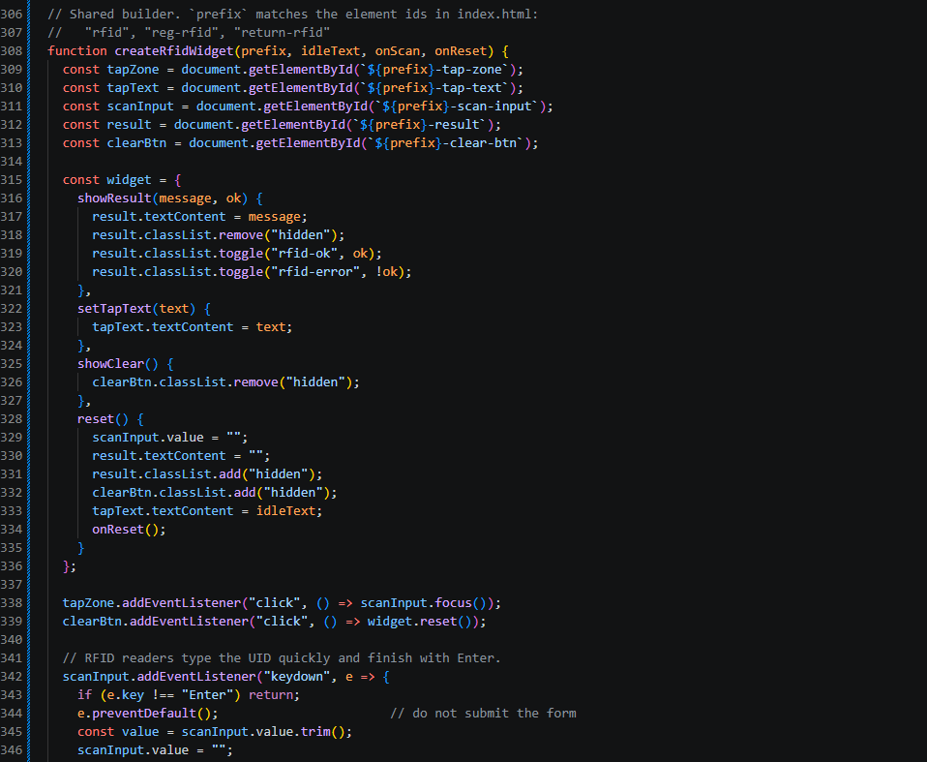

2.
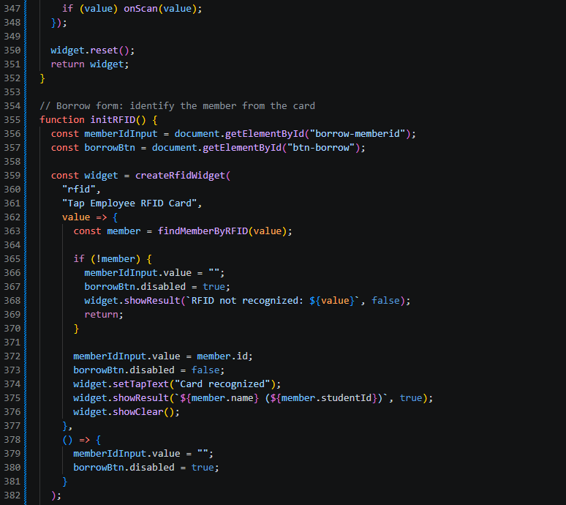

3.
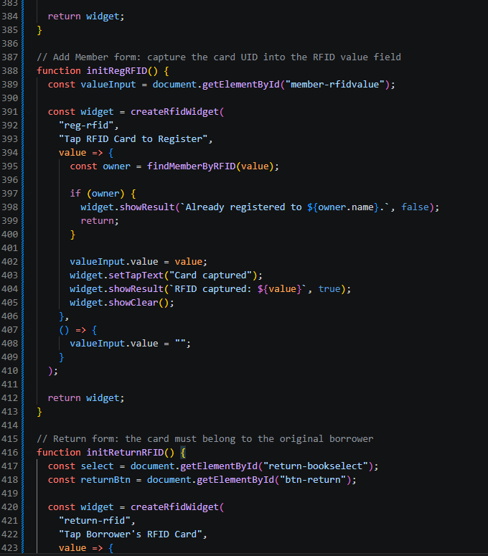

4.
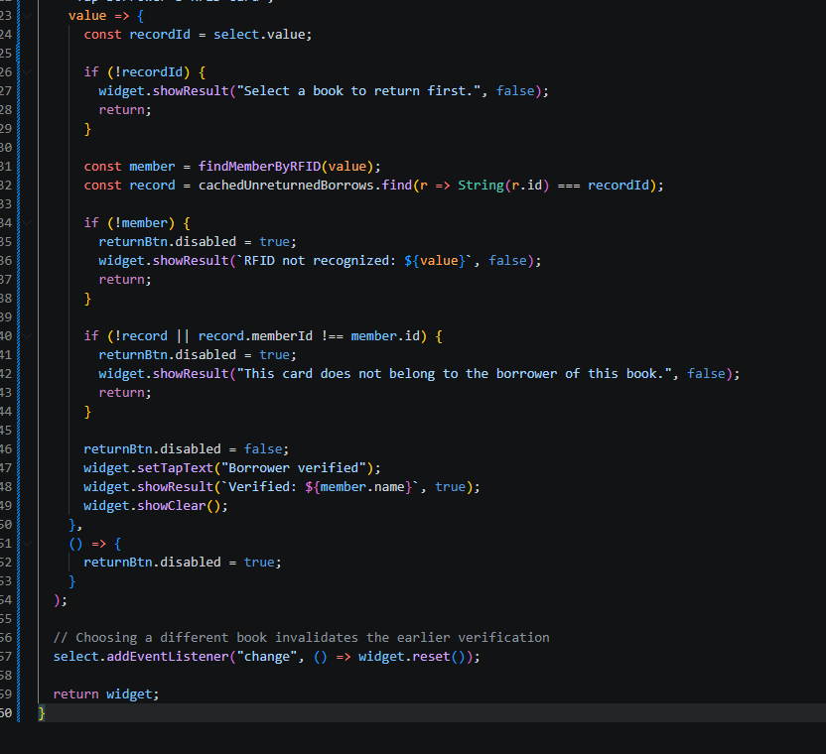

Part 13 — Populate Borrow Book Dropdown

Part-13-borrow-dropdown
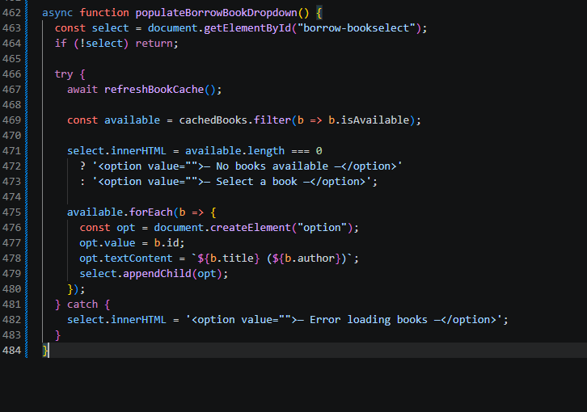

Part 14 — Populate Return Book Dropdown

Part-14-return-dropdown
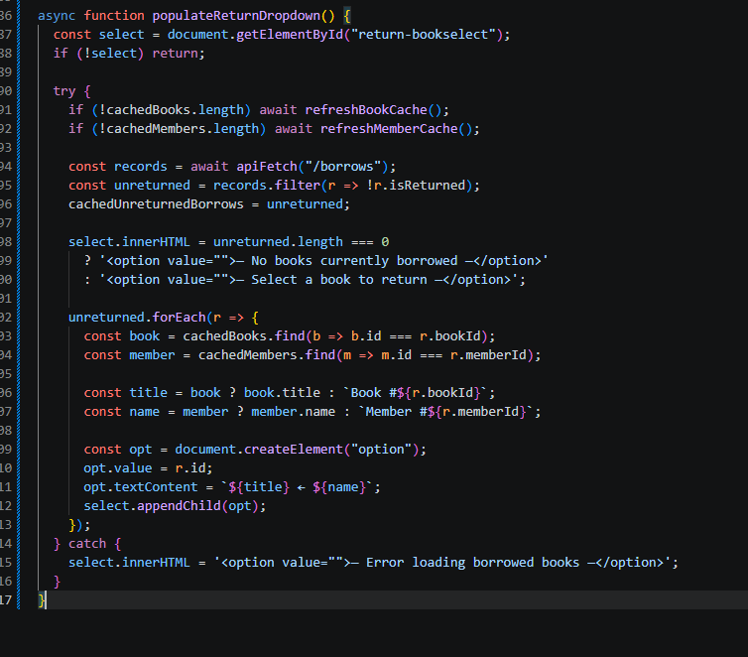

Part 15 — Borrow a Book

Part-15-borrow
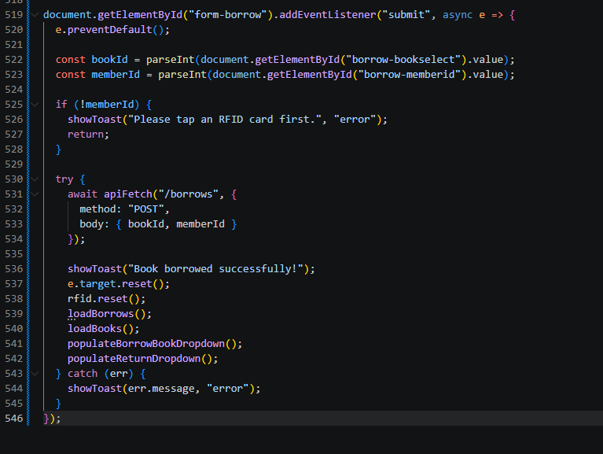

Part 16 — Return a Book

Part-16-return
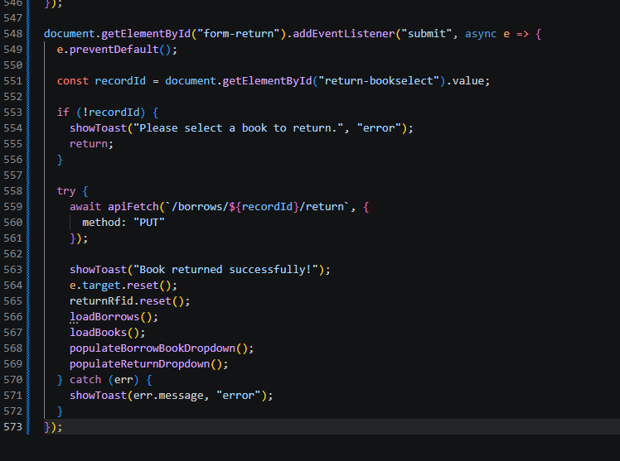

Part 17 — Load Borrow History Table

Part-17-loadborrows
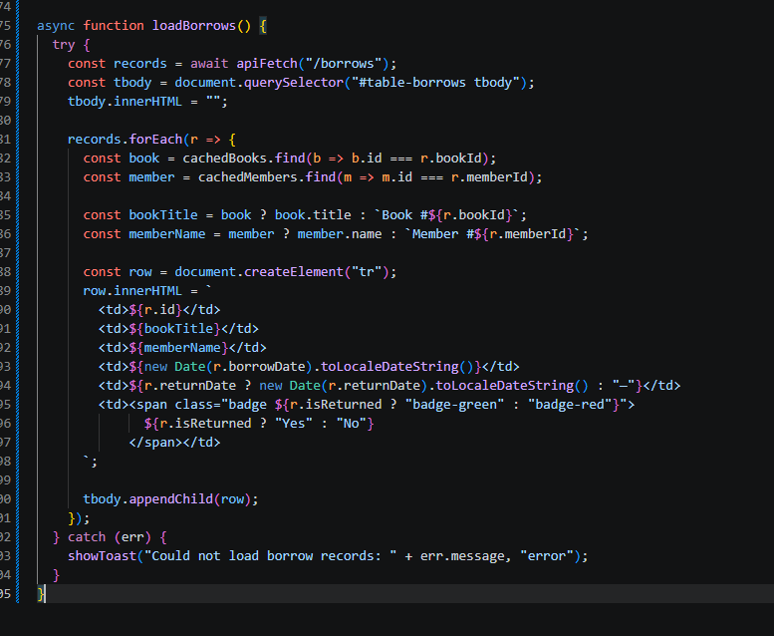

Part 18 — Initial Page Load

Part-18-page-load
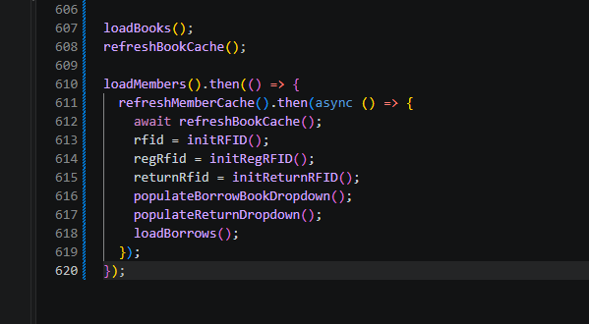

TESTING STEPS

1. Start the API
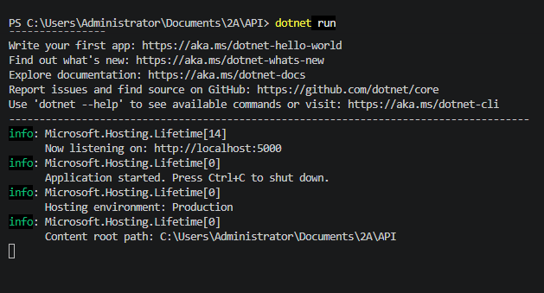

2. Open the FrontEnd
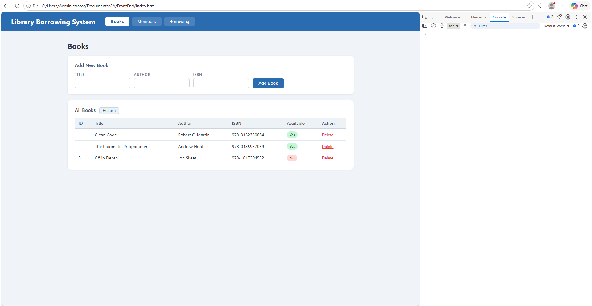

3. Test the Tabs
The tabs were already captured in early-03-tabs. No new screenshot here

4. Test Books
Add
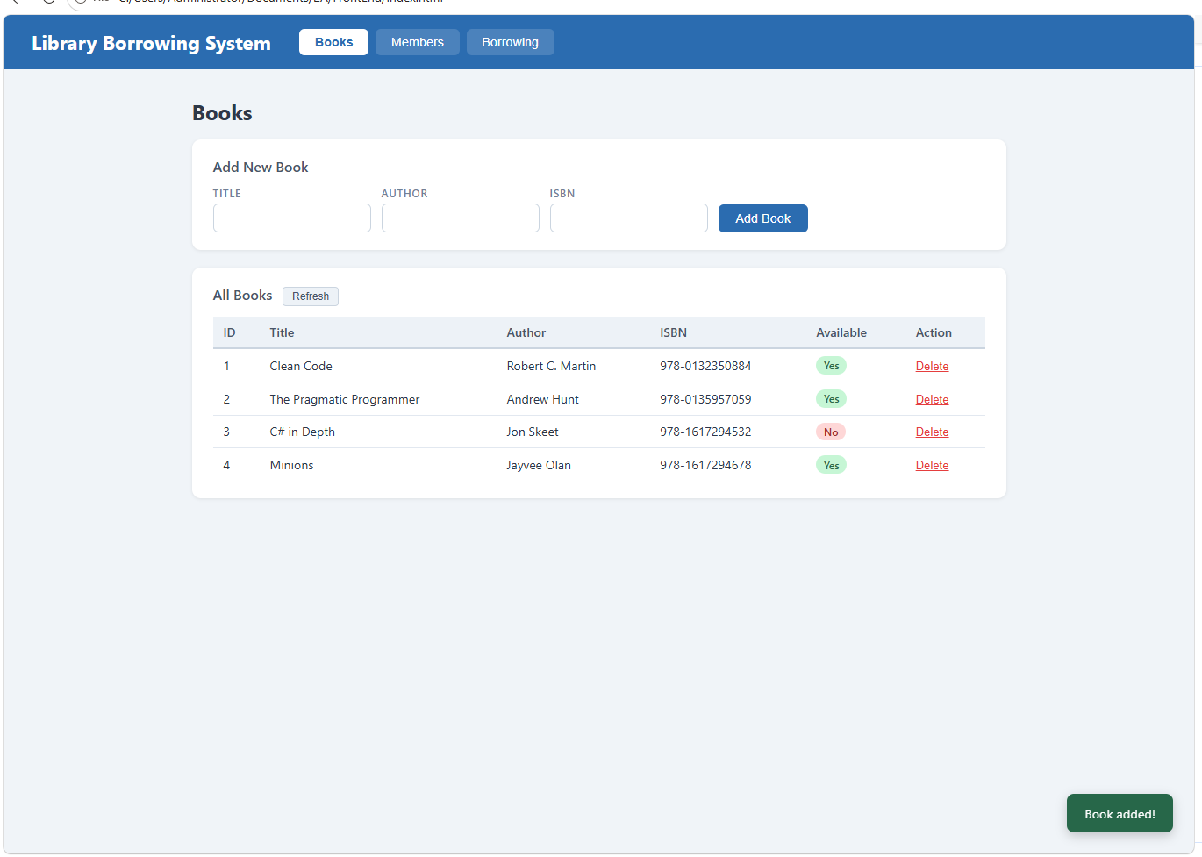

Delete
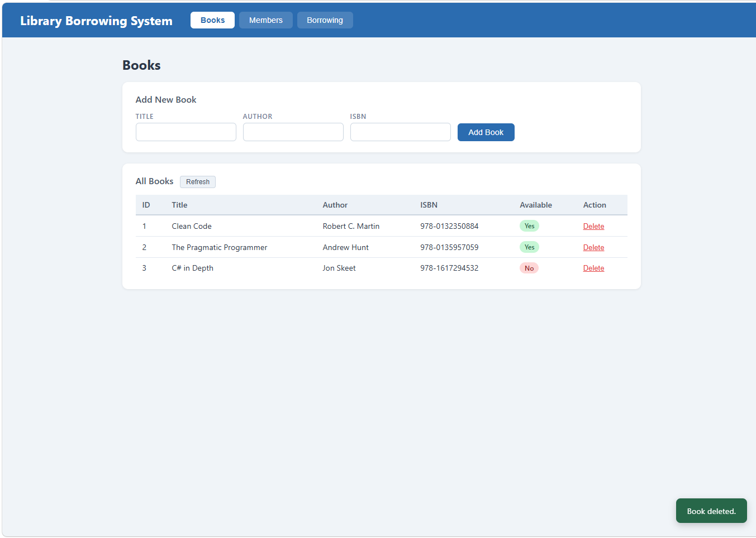

5. Test Members
test-04-members-loaded
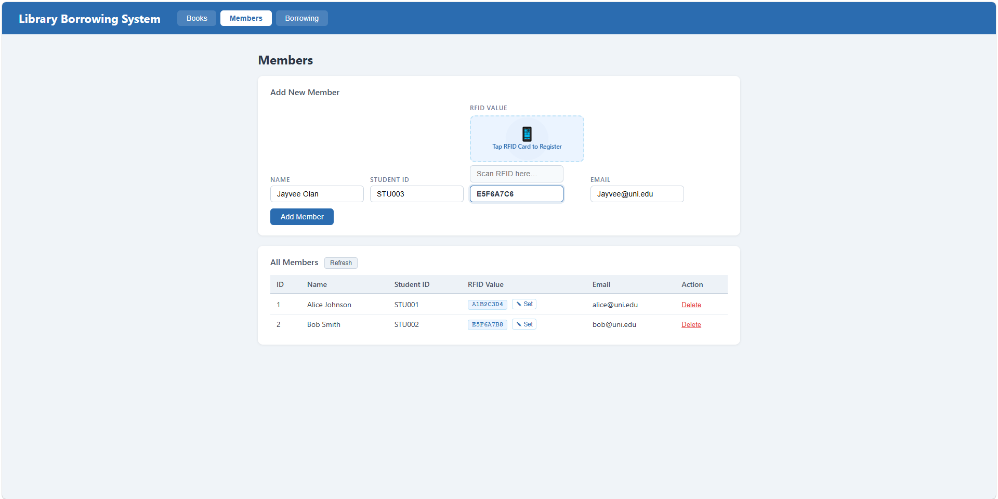
test-05-register-rfid
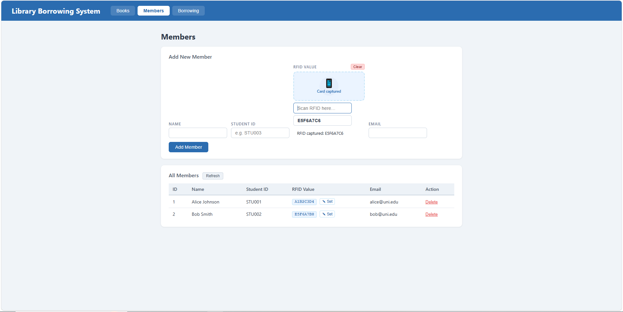

test-06-add-member
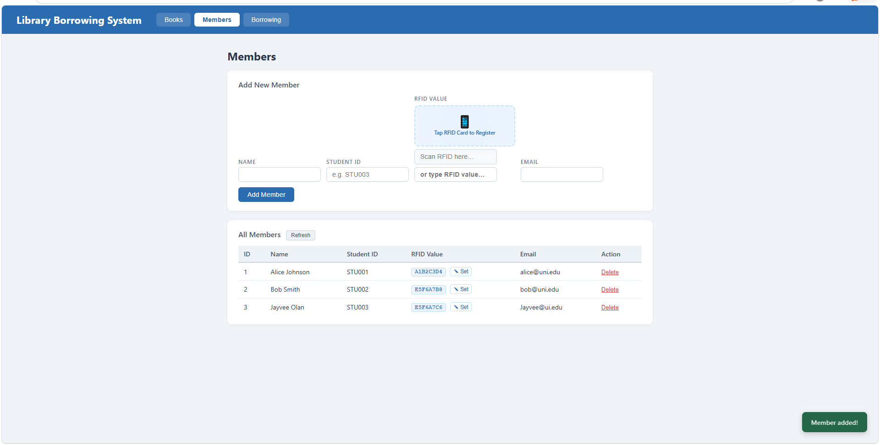
test-07-set-rfid-saved
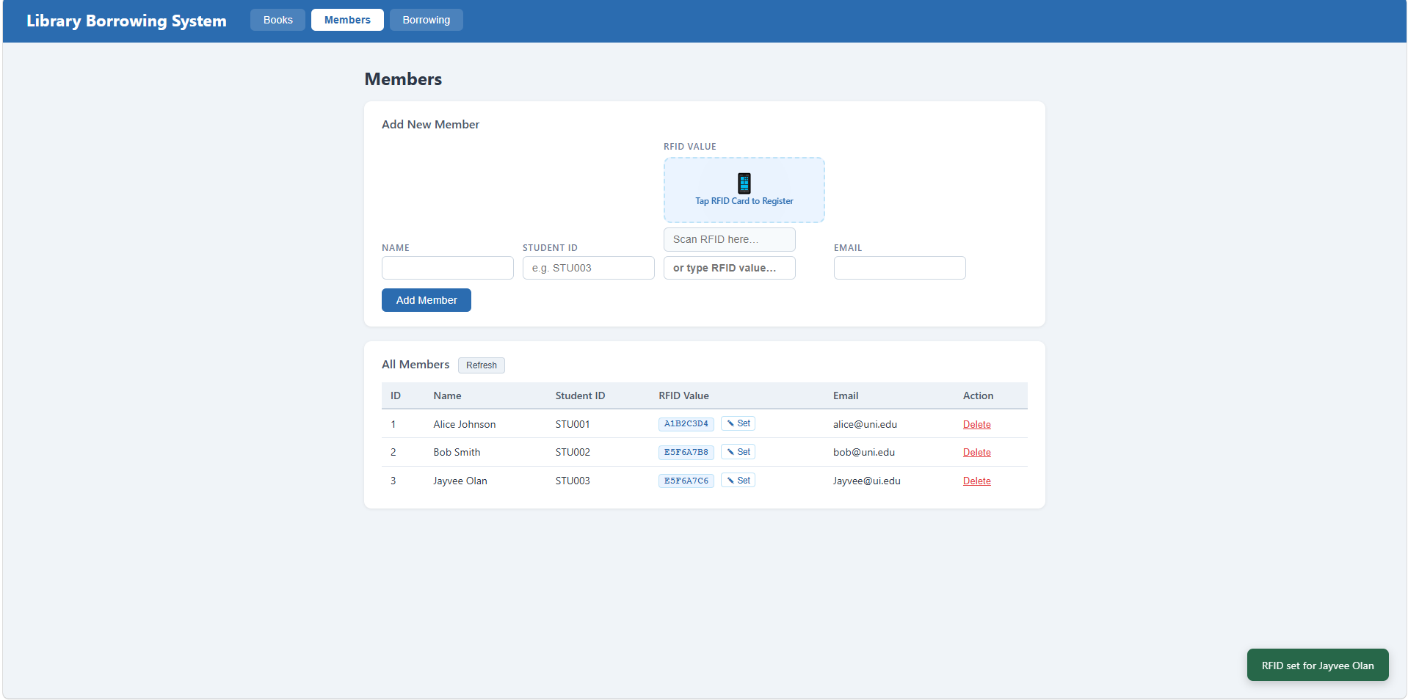

test-08-delete-member
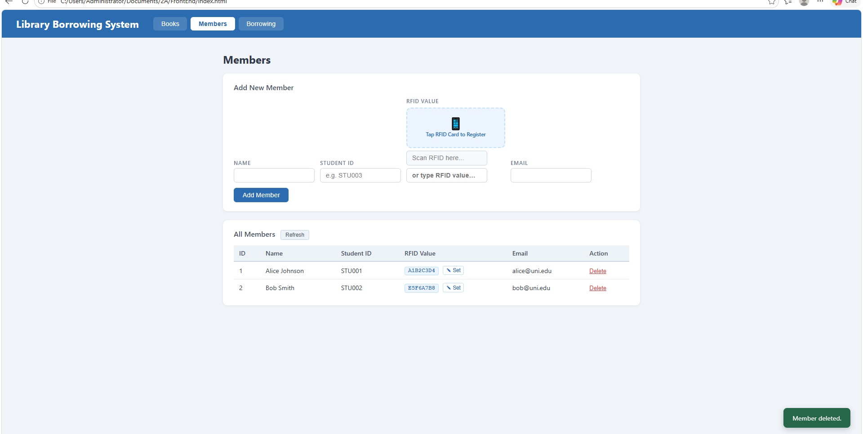

6. Test Borrowing
test-09-borrow-rfid-recognized
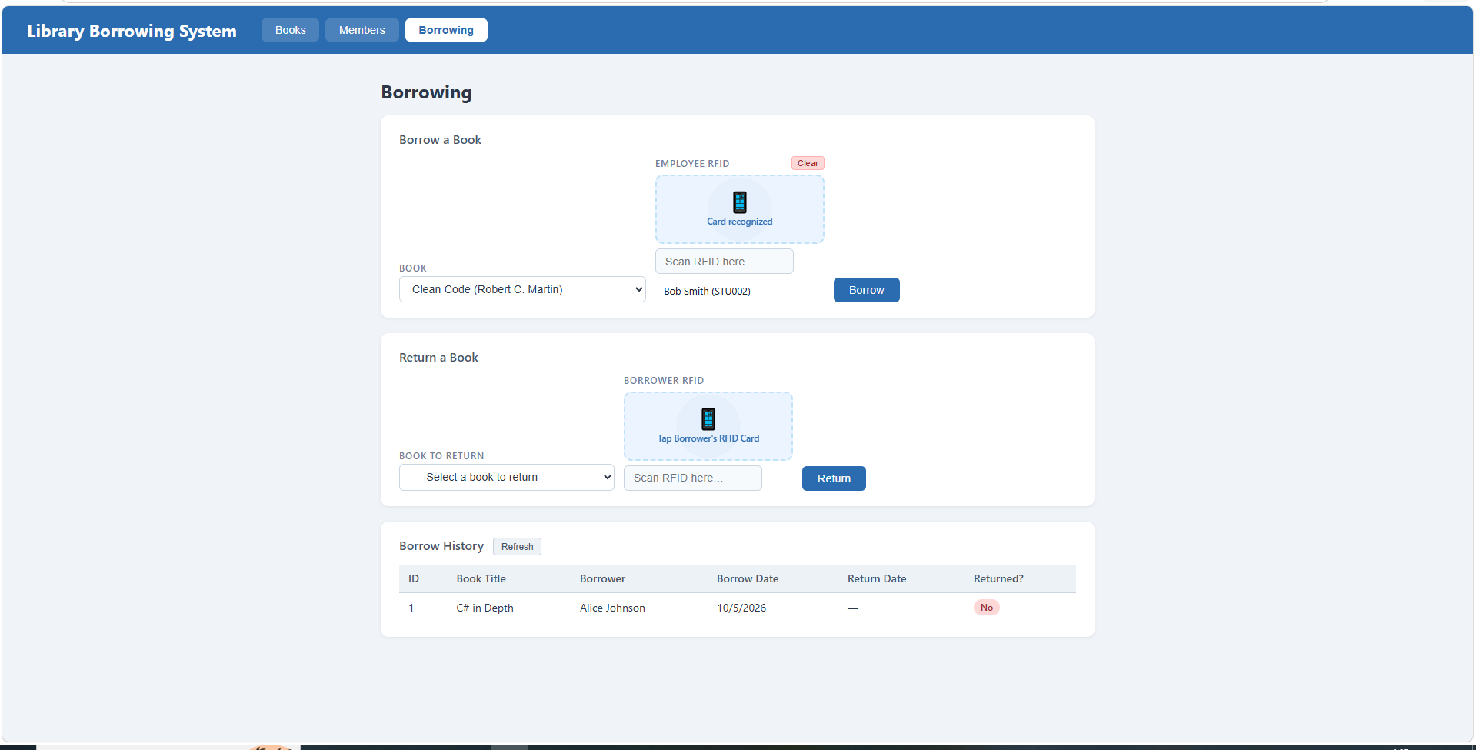

test-10-borrow-success
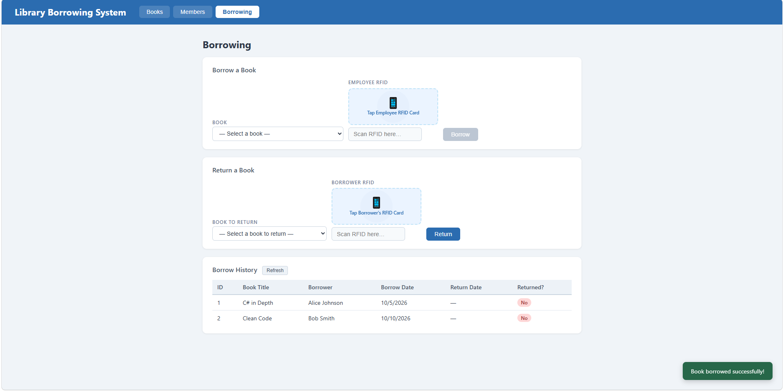

7. Test Returning
test-11-return-wrong-card
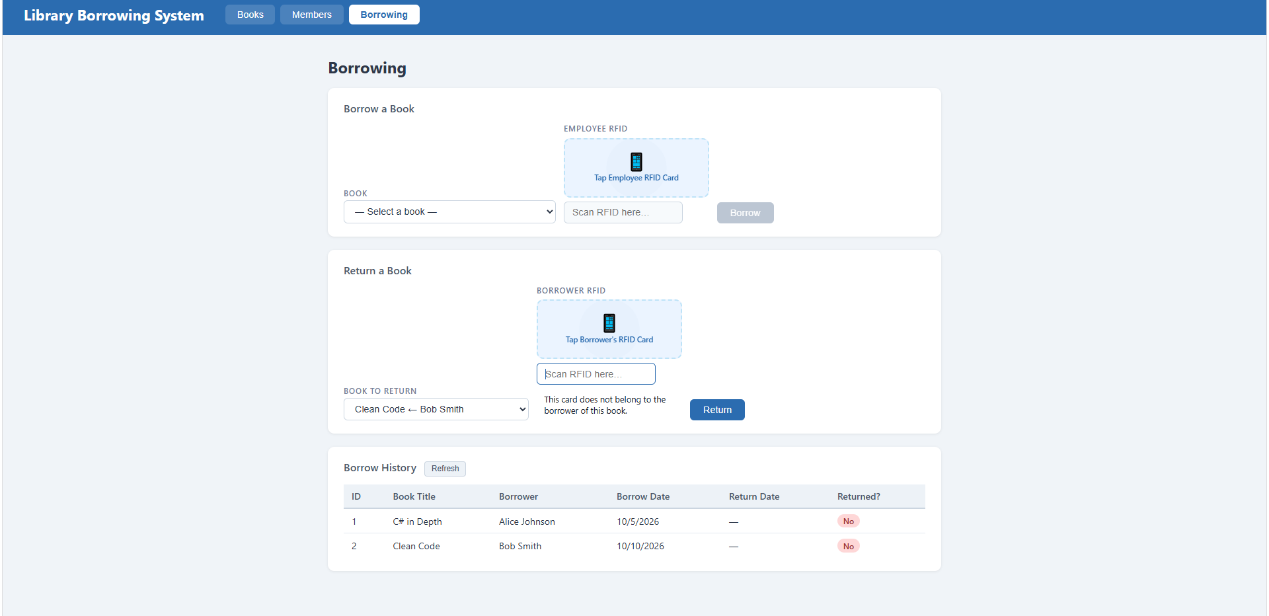
test-12-return-verified
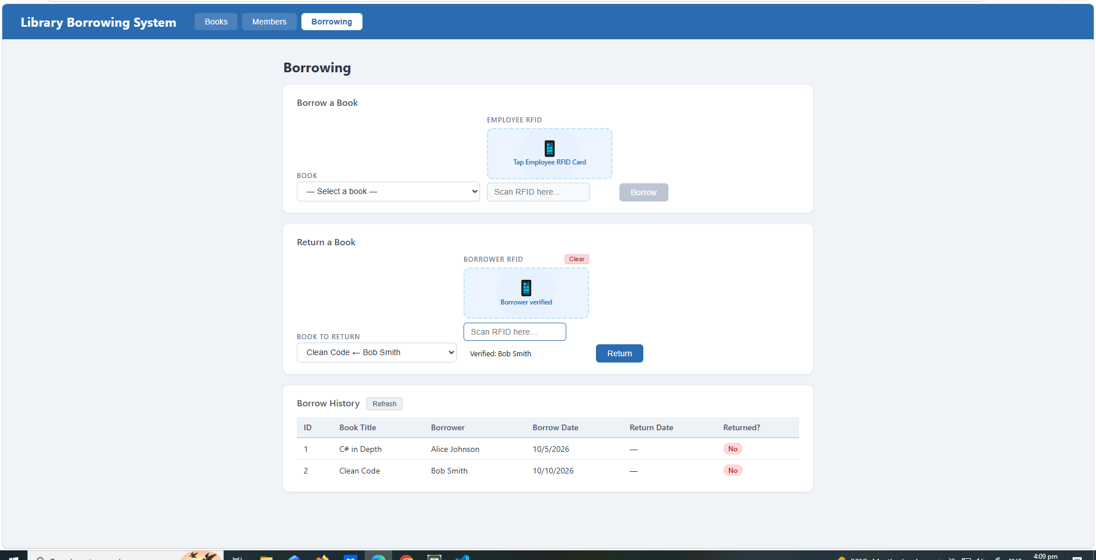

test-13-return-success
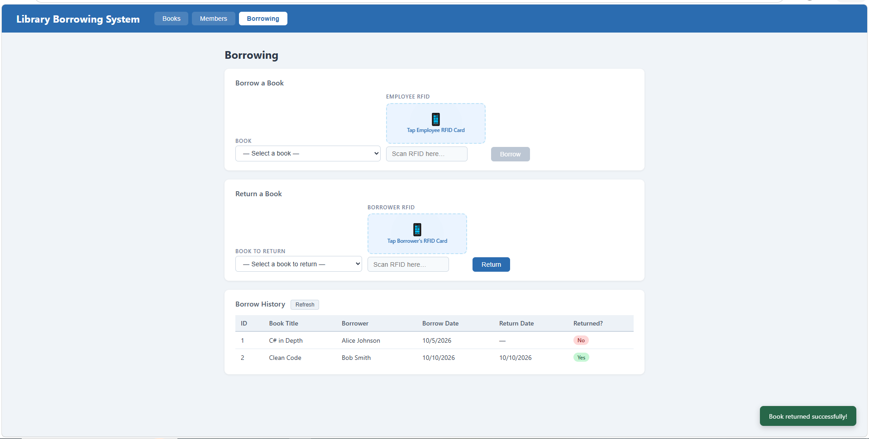

8. Final Console Check
test-14-final-console
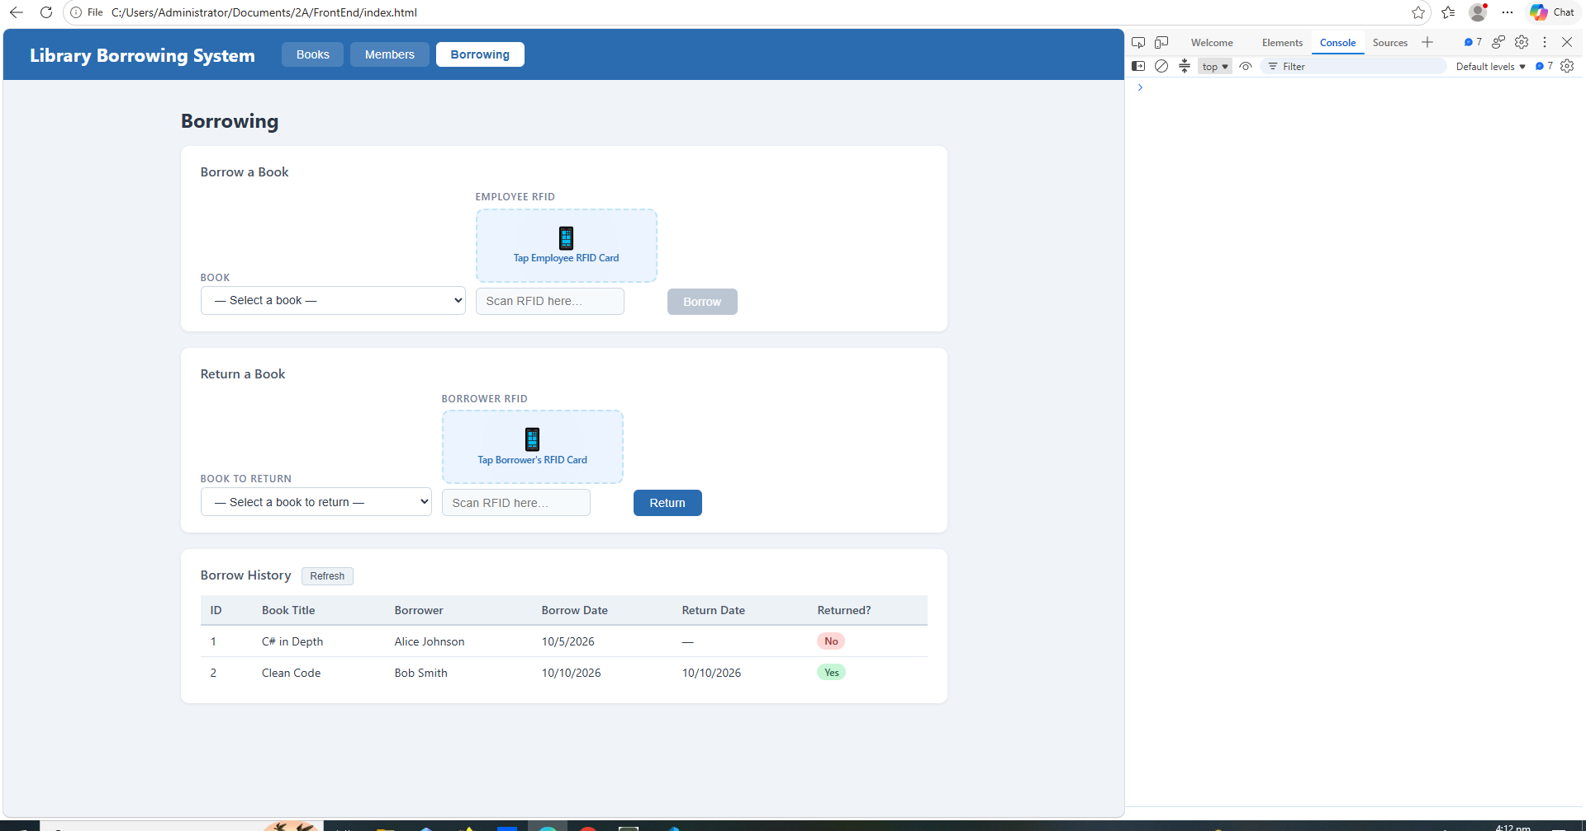

Reflection Questions
- What does apiFetch() do?
Its a helper function that handles our http request to the backend API and converts the servers response into JSON format so we can use it easily in our code
- Why do we use try/catch around API calls?
We try and catch to handle network or server errors gracefully, making sure the website doesn't crash or get stuck in an api request fails
- What is the difference between POST and PUT?
We use post when creating a new record on the server, while put is used when updating or modifying an existing record
- Why does RFID matching use rfidValue instead of studentId?
The RFID scanner reads the unique hardware code printed on the physical card, so we use that value to look up and match the student in the database
- Why do we refresh tables after adding, deleting, borrowing, or returning?
Refreshing fetches the latest data from the database, ensuring the user interface updates immediately to reflect the new state
- Why does the Return dropdown use a borrowed record ID instead of book ID?
The borrow record ID points to specific transaction details, while a book ID only identifies the book itself
- What happens if the same event listener is added to a form twice?
The event handler function will trigger twice every time the form is submitted, causing duplicate API request and saving duplicate data
- Why must the page-load code be at the bottom of the file?
Putting it at the bottom makes sure all html elements and helper and function are fully loaded into the memory before the initial scripts start running
- Why does an RFID reader need e.preventDefault() on the Enter key?
RFID scanners automatically send Enter keypress right after scanning a code so e.preventDefault() prevents the browser from reloading the page or submitting forms unexpectedly

